# 2. Context of Use

## 2.1 Primary Users

The wandering detection app is mainly meant to be utilised by caretakers, who are typically spouses or close family members of dementia patients. These caretakers are often elderly individuals who may lack familiarity with the latest technologies. The app's design is required to emphasise accessibility, with an easy interface that allows caretakers to easily monitor their loved ones' location, movements, and vital signs.

The interface is to be built with simplicity in mind, with clear instructions, big, easily recognisable icons, and minimal navigational steps required to access important services. Furthermore, while the interface should be geared towards less tech-savvy users, it should still have complex functions that may be used by younger or more digitally capable family members. However, the design's primary role remains to provide accessibility for individuals who are inexperienced with digital technologies.

**Goals of Primary User:**

* Ensuring the safety of those with dementia and providing real-time surveillance to avoid straying into risky circumstances.
* The app should be simple to use and provide rapid access to important data like location and health indicators.
* Carers need rapid notifications if a person with dementia wanders outside pre-selected safe zones or if their vital signs change significantly.

## 2.2 Secondary Users

The secondary user is a person with dementia, who is vulnerable and may be unaware of their surroundings or activities. This user's interface with the system is indirect, via a wearable gadget, i.e. a watch, that monitors their position and vital signs. Comfort and simplicity of use are the primary design factors for this group. The watch must be inconspicuous and comfortable, without causing distress or pain. While the person with dementia will not interact directly with the app, the data captured by the wearable device must be safely and reliably delivered to guarantee effective monitoring without needing active participation from the secondary user.

**Goals of Secondary Users:**

**• Comfort:** The wearable gadget should be lightweight, non-intrusive, and comfortable enough to be worn all day without discomfort.

• **Non-disruptiveness:** The gadget should work smoothly without attracting attention or generating confusion for the user.

• **Safety:** The gadget must track the user's location and health indicators to ensure their safety without requiring their direct engagement.

## 2.3 Tertiary Users

Tertiary users are a larger network of people and organisations involved in the person's dementia safety and care. Other family members, local police stations, hospital physicians, nurses, and other stakeholders are also involved. Each of these users, interact with the system differently, but they all need access to accurate and timely information.

* **Family members** must be updated about the individual's whereabouts and health state, especially the ones providing care.
* **Police and emergency services** need location data and alerts to respond quickly if a person with dementia is reported missing.
* **Healthcare professionals** can monitor the individual's health data to make informed care decisions.

**Goals of Tertiary Users:**

* The system should offer real-time, accurate data to all necessary stakeholders for effective coordination and reaction.
* The app should promote communication and collaboration across various user groups, such as family members, law enforcement, and healthcare professionals, to ensure an individual's well-being.
* Healthcare workers need access to essential health measurements that might impact treatment decisions and emergency response.

## 2.4 Environmental Factors

**Physical Environment:**

* **Home Environment:** The app must accurately detect if an individual has left their house or reached a dangerous place. The system must include common household layouts and potential safe zones.
* **Outdoor Environment:** The app must be able to manage outside conditions, including those with risks like streams, busy highways, or unknown territories.

**Technological Environment:**

* **Wearable Device:** The app is based on a GPS and SIM enabled watch, which must maintain strong contact with the mobile app to provide continuous and reliable monitoring.
* **Mobile Devices:** The app is to be optimised for smartphones and tablets, considering users' technological ability levels.

**Social Environment:**

* **Family Dynamics:** The app must provide good communication and coordination among family members, ensuring that everyone participating in caregiving is aware and able to contribute.
* **Healthcare Interaction:** The app should give healthcare professionals access to the data they need to make educated decisions regarding their patients' treatment.

**Artifacts:**

* **Wearable Device:** The watch must be comfortable, long-lasting, and secure, with features that prevent tampering or removal by the user.
* **Mobile Interface:** The app’s user interface should prioritise accessibility for older, non-tech-savvy users, while still providing sophisticated choices for individuals with more technical knowledge.

# 3. Models

## 3.1 User Model - Persona

**Primary Persona:**

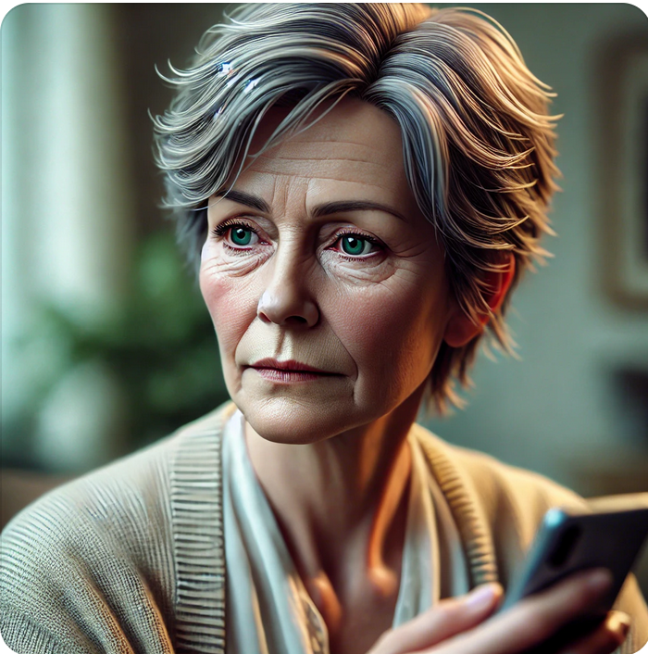

**Name:** Catherine Starc  
**Age:** 66  
**Role:** Caregiver

**Address:** Unit 6, Bulleen Drive, Mount Evelyn

**Background:**  
Catherine Starc is a 66-year-old retired schoolteacher living in Mount Evelyn, an eastern suburban region of Melbourne. Her home is nestled near the base of the mountains, with the vast, dense forests stretching to the east. This picturesque location, while beautiful, presents a unique and terrifying challenge: the possibility of her husband, Edward Starc, wandering off into the wilderness. Edward, diagnosed with early-stage dementia, has recently begun to wander off unknowingly, leaving Catherine in a constant state of anxiety. The fear that Edward might get lost in the wilderness haunts Catherine, especially with the knowledge that someone lost in the woods, could face life-threatening conditions, particularly during winter when temperatures plummet below 5°C. This constant worry shadows her every day, as she struggles to keep Edward safe. Each day, she struggles to balance her routine with the overwhelming need to keep Edward within sight, fearing that one moment of inattention could lead to a life-threatening situation.

**Technology Use:**  
Catherine’s use of technology is **minimal**; her smartphone is mainly for calls and messages. She feels overwhelmed by complicated apps and gadgets but understands that she needs a reliable, easy-to-use solution to monitor Edward, especially given the dangerous environment surrounding their home.

**Goals:**

* **Prevention of Wandering Incidents:** Catherine’s primary goal is to prevent Edward from wandering off, particularly into the nearby forests or mountains, and to be able to locate him immediately if he does.
* **Real-Time Alerts:** She needs a system that will notify her the moment Edward leaves the safety of their home or designated safe zone areas, allowing her to act swiftly before he ventures too far into dangerous terrain.
* **Preparing for Worsening Conditions:** Catherine seeks a reliable solution that will evolve with Edward’s condition, ensuring she is prepared for the increased risks as his dementia progresses.

**Frustrations:**

* **Unreliable Solutions:** Catherine is frustrated by the lack of simple, reliable tools that can help her monitor Edward effectively, especially considering the high-risk environment they live in.
* **Tech Anxiety:** The fear that she might not be able to navigate an app quickly enough in an emergency situation, is a constant source of anxiety.
* **Constant Vigilance:** The need to constantly watch over Edward is exhausting, and she worries about what will happen if his condition worsens, particularly with the added risk of their location.

**Quote:**  
“I’m terrified that one day Edward will wander off into the forest, and I won’t be able to find him in time. I need something that can help me keep him safe, especially in this environment.”

**Key Attributes:**

* **Diligent and Caring:** Catherine is deeply committed to Edward’s well-being, always prioritizing his needs and doing everything in her power to keep him safe.
* **Cautious with Technology:** While Catherine understands the importance of technology in her situation, she needs something intuitive and easy to use, without adding to her stress.
* **Proactive and Prepared:** Living in a high-risk area, Catherine is constantly thinking ahead, seeking out solutions that will help her manage Edward’s care as his dementia progresses.

**Tasks:**

* **Monitoring Edward’s Movements:** Catherine regularly checks any tools or apps available to ensure Edward hasn’t wandered off, especially towards the nearby forests and mountains.
* **Setting Safe Zones:** She carefully defines and adjusts safe zones within the app, balancing Edward’s need for independence with the necessity of keeping him within safe, easily monitored areas.
* **Exploring Future Solutions:** Catherine is always researching and considering more advanced monitoring options, knowing that Edward’s condition may worsen and that the risks in their environment are significant.